**Practical -1**

**Installation of Android Studio and running first app.**

**1 – Setting Up Android Studio.**

**Steps:-**

Step-1: Download Android Studio From <https://developer.android.com>

After Completion of Download. Click on .exe File And Start Installation.

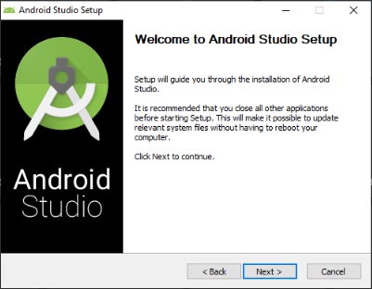

Click On Next.

Step-2: Select Checkbox and Click On Next Button.

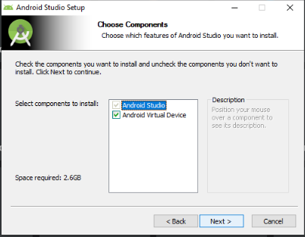

Step-3: Select Path Where You want to Install.

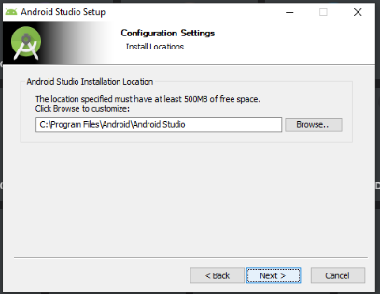

Step-4: Select Start Menu Folder As Android Studio. And Click On Install

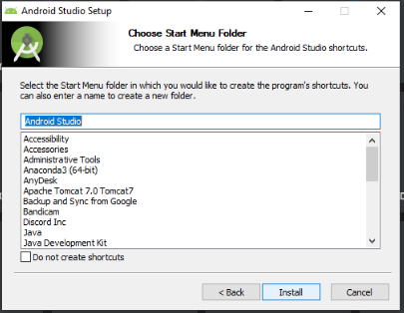.

Step-5: Installation will be Begin.

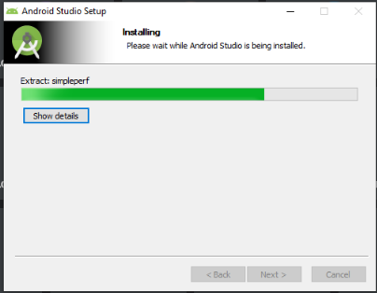

Step-6: After Installation Following Window Will Appear.

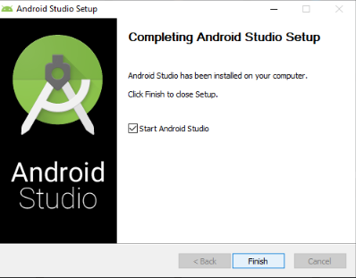

Step-7: Click Finish and Following Dialog box will be shown, click on “do not import setting” as we do not have any previous installation of Android Studio in Our System. Then Click On ok Button.

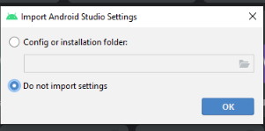

Step:8: It Will start Android Studio and find sdk Components. After finding sdk components it will Shown following Window. And Click on Next.

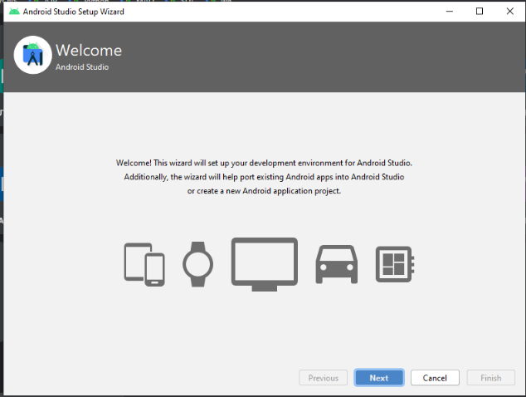

Step-9: Select type of setup you want to run and click next then verify your setting and downloading of components will start. After completing download your android studio is ready to launch.

**2 – Creating A New Project.**

**Ans:**

Step-1: Select Create New Project.

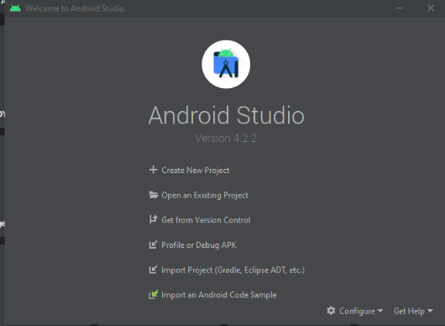

Step-2: Select the Activity Template for Your Project.

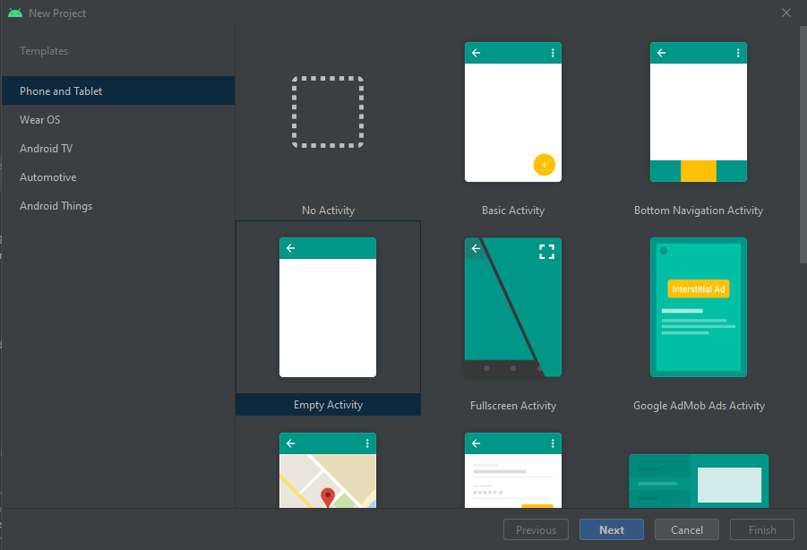

Step-3: It will Ask you for the saving Location, Name, Package Name (Package Name Should be Different so that at the execution time it will not configure).

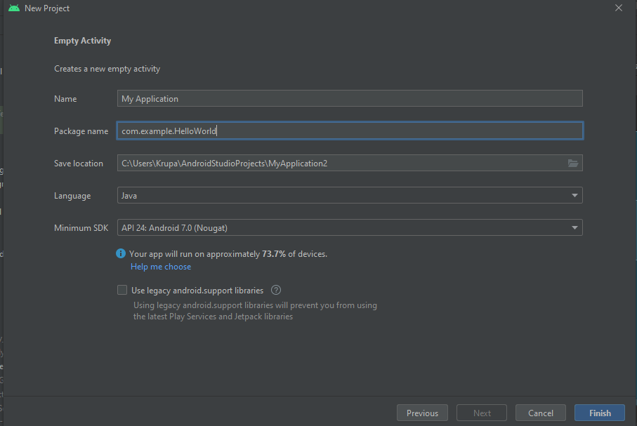

Step-4: After Android studio Loads, click on **activity_main.xml** file, that will open following window.

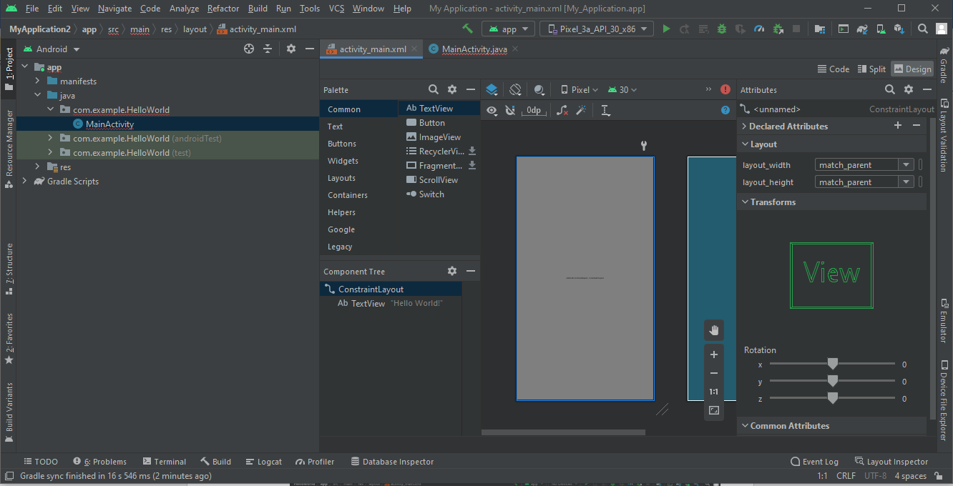

Step-5: This Screen shows the design view. You can See that there is already written on the apps user interface.

You can Change that by going in coe view and edit it.

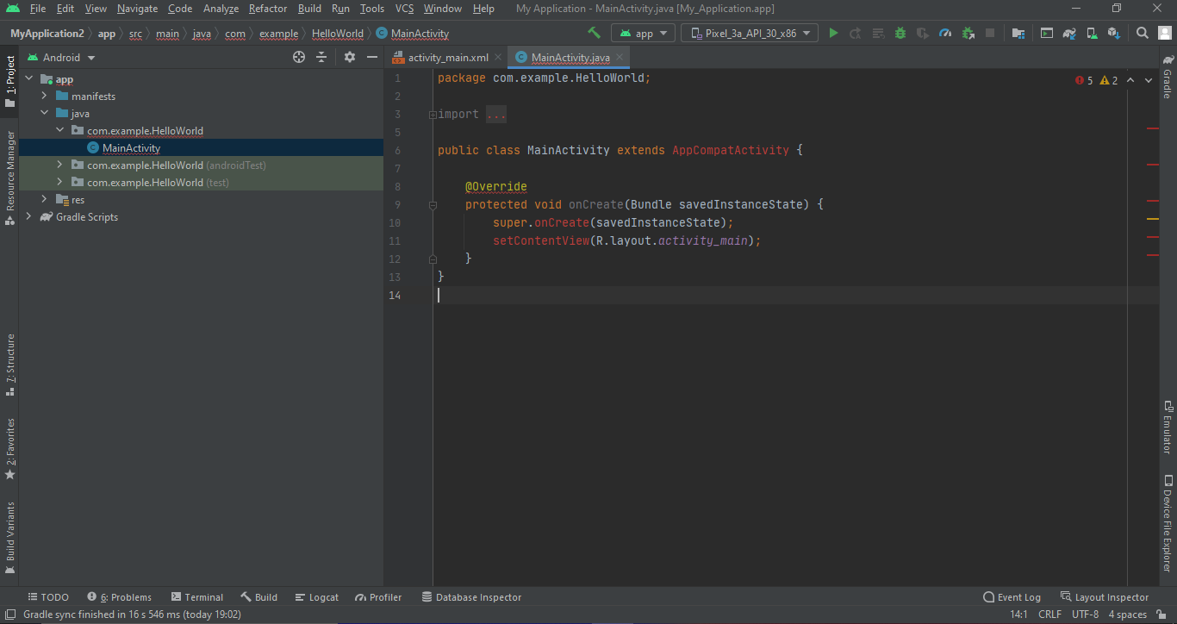

Step-6: Then go to Tools>AVD Manager>Virtual Device. Then following Dialog Box will Appear.

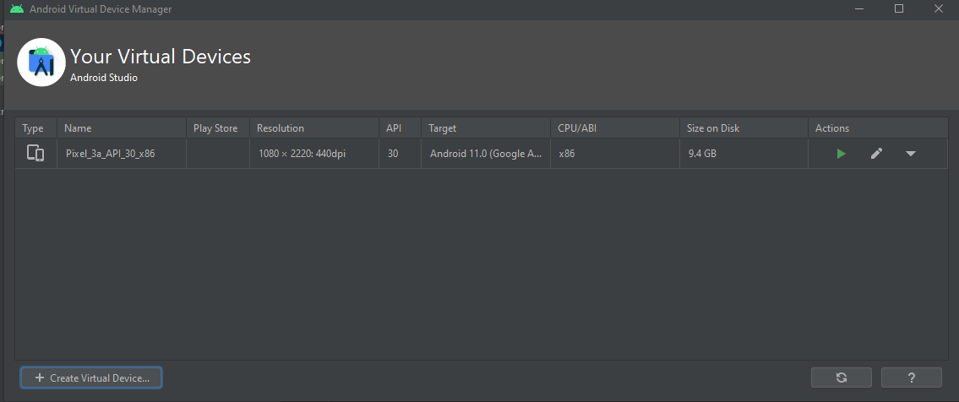

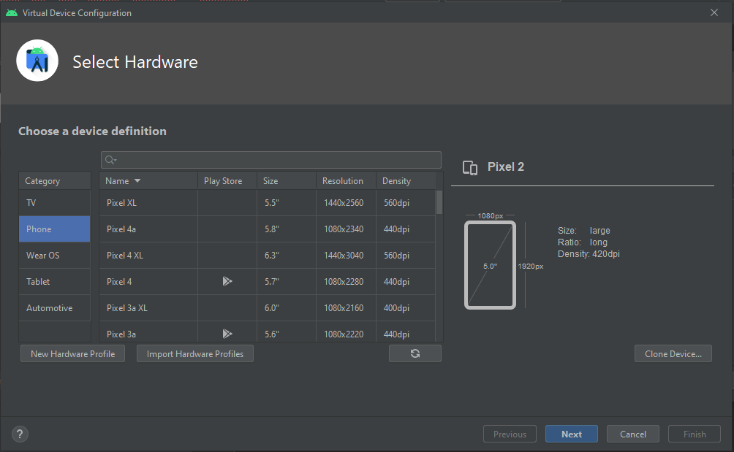

Click On Next.

Step-7: Then Select Appropriate System and System Image.

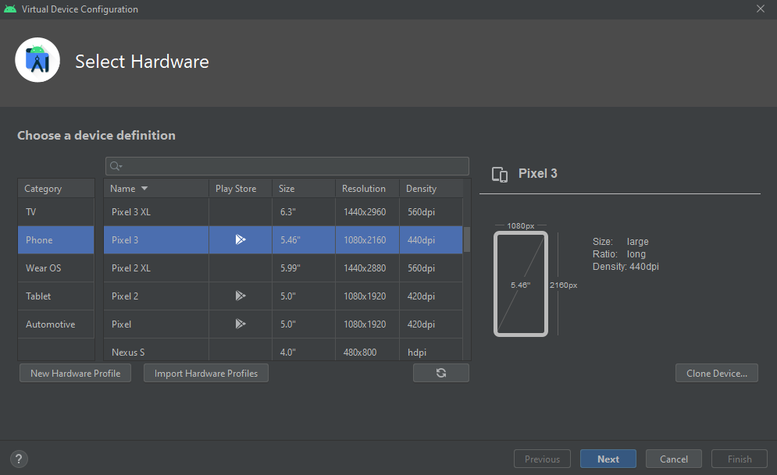

For that Download the required System Image.

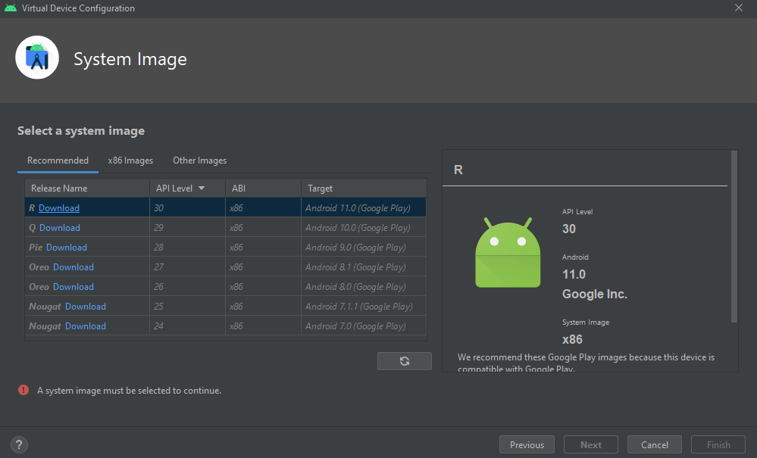

I download Oreo 26 API level.

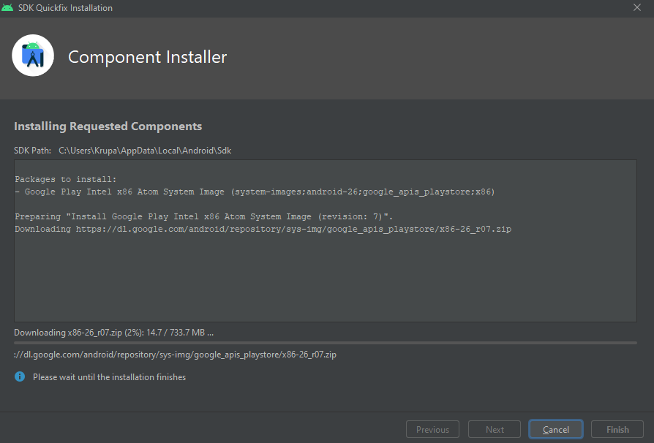

Step-8: Select Start up Orientation whether you want Portrait or Landscape mode And Click on Finish.

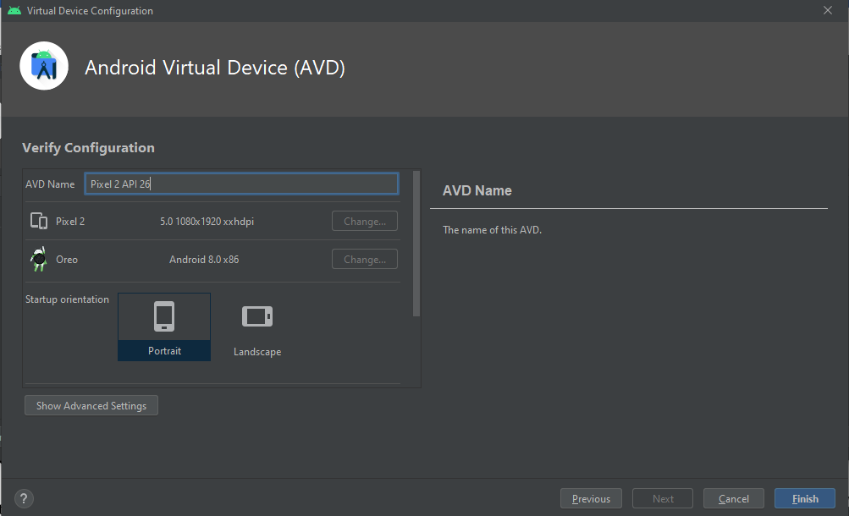

Step-9: After Successfully Creating AVD. Click on run Icon to run your application.

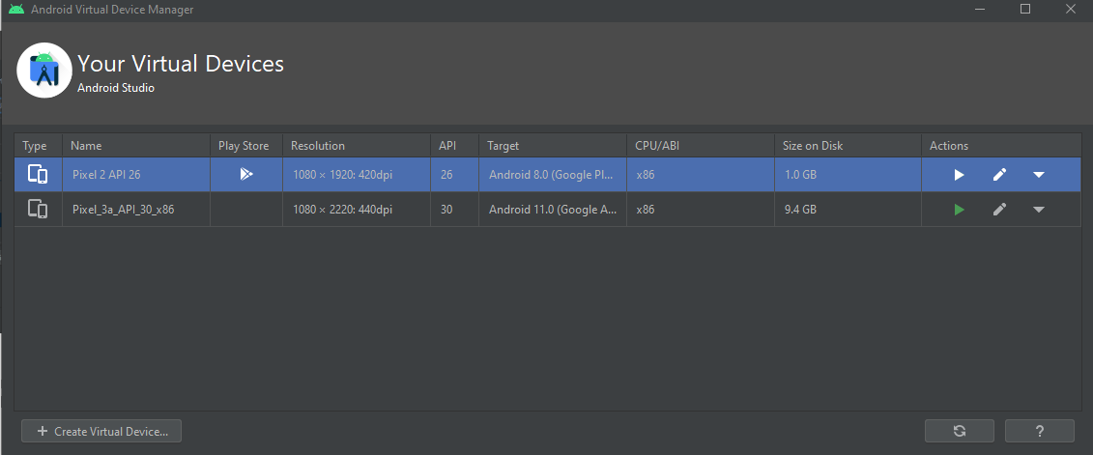

**Q-2: After Successfully Creating AVD. Click on run Icon to run your application.**

